E - LIBRARY
22VPO03 – MINI PROJECT
A PROJECT REPORT
Submitted by
SANCHAY M
22CSR172
SANTHOSH P
22CSR177
in partial fulfilment of the requirements for
the award of the degree
of
BACHELOR OF ENGINEERING
IN
COMPUTER SCIENCE AND ENGINEERING
DEPARTMENT OF COMPUTER SCIENCE AND ENGINEERING

KONGU ENGINEERING COLLEGE
(Autonomous)
PERUNDURAI ERODE – 638 060
NOVEMBER 2024

DEPARTMENT OF COMPUTER SCIENCE AND ENGINEERING
KONGU ENGINEERING COLLEGE
(Autonomous)
PERUNDURAI ERODE – 638 060
NOVEMBER 2024

BONAFIDE CERTIFICATE

This is to certify that the Project report entitled E - LIBRARY is the bonafide record of the project work done by SANCHAY M (Register No: 22CSR172), SANTHOSH P (Register No: 22CSR177) in the partial fulfillment of the requirements for the award of the Degree of Bachelor of Engineering in Computer Science and Engineering of Anna University Chennai during the year 2024-2025.

SUPERVISOR HEAD OF THE DEPARTMENT
Date: (Signature with seal)

Submitted for the end semester viva voce examination held on ___________ .

KONGU ENGINEERING COLLEGE
(Autonomous)
PERUNDURAI ERODE – 638 060
NOVEMBER 2024
DECLARATION

We affirm that the Project Report titled E - LIBRARY being submitted in partial fulfillment of the requirements for the award of Bachelor of Engineering is the original work carried out by us. It has not formed the part of any other project report or dissertation on the basis of which a degree or award was conferred on an earlier occasion this or any other candidate.
SANCHAY M
(22CSR172)
SANTHOSH P
(22CSR177)

Date:
I certify that the declaration made by the above candidate is true to the best of my knowledge.

Date: Name and Signature of the Supervisor

ABSTRACT

This E-Library is an efficient digital solution to streamline library operations and enhance the user experience. Users can register, log in, and explore a vast catalog of available books. The application allows users to request books online, which the admin can then approve, granting them access to the selected materials. Users can also subscribe to a premium service, which provides them with exclusive access to all available books. The system includes automated calculations for fees and fines based on book rental duration and any delays in return. Additionally, payments can be managed directly through the application, making it a convenient, one-stop solution.
Admins have a comprehensive dashboard for managing the library's catalog. They can add new books, delete obsolete ones, and handle user requests by granting access for specific durations. This access period is automatically tracked, helping to streamline return and renewal processes. A QR code scanning feature is integrated for quick book check-ins and check-outs, enhancing operational efficiency. Overall, this E-Library provides a user-friendly and systematic approach to digital library management, benefiting both users and administrators through automation and easy access.

ACKNOWLEDGEMENT

We express our sincere thanks and gratitude to Thiru. A. K. ILANGO B.Com., M.B.A., LLB., our beloved Correspondent, and all other philanthropic trust members of Kongu Vellalar Institute of Technology Trust who have always encouraged us in academic and co-curricular activities.
We are extremely thankful with no words of a formal nature to the dynamic Principal Dr. V. BALUSAMY, M.Tech., Ph.D., for providing the necessary facilities to complete our work.
We would like to express our sincere gratitude to our respected Head of the Department Dr. S. MALLIGA, M.E., Ph.D., for providing the necessary facilities.
We extend our thanks to Mr. N. ARAVINDHRAJ, M.E., Assistant Professor, Computer Science Engineering, Project Coordinator for his encouragement and valuable advice that made us carry out the project work successfully.
We extend our gratitude to our Supervisor Ms. S. MOHANA SARANYA, M.E., Assistant Professor of Computer Science Engineering, for her valuable ideas and suggestions, which have been very helpful in the project. We are grateful to all the faculty members of the Computer Science and Engineering Department, for their support.

TABLE OF CONTENTS
CHAPTER No. TITLE PAGE No.
ABSTRACT IV
LIST OF FIGURES VIII
1. INTRODUCTION 1
1.1 EXISTING SYSTEM 1
1.2 SYSTEM STUDY 2
1.3 OBJECTIVE 2
1.4 SCOPE 5
2. GENERAL DESCRIPTION 7
2.1 PROJECT PERSPECTIVE 7
2.2 USER CHARACTERISTICS 8
2.3 DESIGN AND 8
IMPLEMENTATION CONSTRAINTS
3. REQUIREMENTS 9
3.1 FUNCTIONAL REQUIREMENTS 9
3.2 NON-FUNCTIONAL REQUIREMENTS 10
3.3 USER INTERFACES 12
4. DETAILED DESIGN 15
4.1 ARCHITECTURAL DESIGN 15
4.1.1 MODULE CHARACTERISTICS 16
4.1.1.1 user module 16
4.1.1.2 admin module 17
4.1.1.3 use case diagram 19
4.1.1.4 sequence diagram 20
4.2 INTERFACE DESIGN 20
4.3 DATABASE DESIGN 21
4.4 OUTPUT DESIGN 21
5. TESTING 22
5.1 UNIT TESTING 22
5.2 REGRESSION TESTING 22
5.3 VALIDATION TESTING 22
5.4 VERIFICATION TESTING 23
5.5 INTEGRATION TESTING 23
6. CONCLUSION AND FUTURE SCOPE 25
APPENDIX 1 26
APPENDIX 2 47 REFERENCES 50
LIST OF FIGURES
FIGURE No. FIGURE NAME PAGE No.
4.1 User flowchart 17
4.2 Admin flowchart 18
4.3 Use case diagram 19
4.4 Sequence diagram 20

CHAPTER 1
INTRODUCTION

Libraries are essential resources for knowledge and learning, offering users access to books, journals, and other materials. However, managing library operations manually can be time-consuming and prone to errors. A E-Library streamlines these processes, enabling efficient handling of tasks such as book tracking, issuing, returning, and managing fines. In today’s digital age, a robust E-Library is essential for providing convenient, remote access to library resources. This system allows users to log in, browse available books, request specific titles, and handle payments and fines directly online. Moreover, it allows administrators to manage the library collection and user access seamlessly. The addition of features like QR code scanning and automated duration tracking further simplifies library operations, making it an effective solution for modern libraries.

1.1 EXISTING SYSTEM
Traditional library systems often rely on manual processes for managing book inventory, tracking due dates, and calculating fines. This approach is prone to errors, such as lost records or incorrect fine calculations, and requires substantial effort from library staff. Existing digital systems may not fully address these issues or lack features such as online book requests, QR code scanning, and automated payment handling. Consequently, libraries can struggle with inefficiencies, limited access to materials, and challenges in tracking user activity. Moreover, many systems lack the ability for users to subscribe to premium services for accessing exclusive content, restricting their reach and usability. A more sophisticated and integrated E-Library can address these limitations.

1.2 OBJECTIVE
The primary objective of this E-Library is to provide a digital platform that streamlines library management processes while enhancing user experience. It aims to enable easy access to book catalogs, allow users to request books online, automate the management of dues and fines, and offer premium subscriptions for expanded access. The system also includes tools for administrators to manage inventory, approve requests, and track book access durations efficiently. Through QR code scanning and automated calculations, the E-Library minimizes manual tasks, reduces errors, and improves resource accessibility. By achieving these objectives, the system will support libraries in offering convenient and organized services to users and administrators alike.

1.3 SYSTEM STUDY
The system study for the E-Library involves analyzing the existing processes, identifying limitations, and determining the requirements and solutions to create a more efficient, user-friendly digital library platform. The study focuses on understanding user needs, system feasibility, and technology integration.

1.3.1 EXISTING SYSTEM ANALYSIS
Traditional library systems typically rely on manual or semi-digital processes that include book registration, user record maintenance, manual book check-ins and check-outs, and fine calculations. Key challenges in these systems are:
- Time-Consuming Operations: Staff manually record book transactions, which can be slow and error-prone.
- Limited Access: Users must visit the library physically to request or borrow books, which restricts access and convenience.
- Inefficient Tracking: Manual tracking of books and users' borrowing history often leads to inefficiencies and occasional data loss.
- Inaccurate Fine Calculations: Manual fine management can lead to calculation errors, impacting revenue and user satisfaction.
To address these issues, a digital solution that integrates book catalog management, online book requests, user authentication, and automated fine calculations is essential.
1.3.2 PROPOSED SYSTEM STUDY
The proposed E-Library aims to create a digital library platform that streamlines library operations and enhances user accessibility. It allows users to log in, view book availability, request books, subscribe for premium access, and automatically manage payments and fines. It also enables administrators to manage book collections, user requests, and premium subscriptions seamlessly.
The key features of the proposed system include:
- User and Admin Authentication: Firebase Authentication will securely manage user and admin login, allowing authorized access to specific features.
- Book Browsing and Preview: Users can explore the library’s book catalog, with detailed previews for each book.
- Online Book Requests: Users can request books online, and the admin can approve these requests.
- Premium Subscription Management: Users can request premium subscriptions for broader access, and admins can manage approvals.
- QR Code Scanning: This feature will allow for quick, accurate check-ins and check-outs of physical books.
- Automatic Fine Calculation: The system will automatically calculate fines based on book return delays, improving revenue management and user accountability.
1.3.3 FEASIBILITY STUDY
A feasibility analysis confirms the practicality of implementing the proposed E-Library using React Native for cross-platform development and Firebase for cloud-based data storage and authentication.
- Technical Feasibility: The E-Library is technically feasible, leveraging Firebase’s database and real-time synchronization capabilities, along with React Native’s cross-platform flexibility for mobile application development.
- Operational Feasibility: The system is user-friendly and simplifies library processes, reducing administrative workload and offering users convenient access to resources. This aligns with the operational needs of modern libraries.
- Economic Feasibility: As Firebase offers a scalable solution with a flexible pricing structure, the E-Library will be economically viable for libraries of various sizes.
1.3.4 SYSTEM REQUIREMENTS
- Hardware Requirements: Smartphones or tablets with internet connectivity for user access; computers or tablets for administrators to manage library data.
- Software Requirements:
  - Frontend: React Native for cross-platform mobile application development.
  - Backend: Firebase for user authentication, database management, and real-time data sync.
  - Payment Gateway: Integration of secure payment systems for subscription management and fine collection.
1.3.5 EXPECTED BENIFITS
- Improved Accessibility: Users can access library resources remotely, view available books, and make requests online.
- Increased Efficiency: QR code scanning, automated fine calculations, and premium subscription management minimize manual tasks.
- Enhanced User Experience: The system provides an intuitive, responsive interface that simplifies the library experience for users.
- Better Resource Management: Admins can efficiently manage book inventories, user requests, and financial transactions.

1.4 SCOPE
The scope of this E-Library includes functionalities for both users and administrators. For users, it offers options to browse and request books, pay fines, and access premium services. The system will automatically track book rental durations, calculate fines, and handle payments, reducing administrative overhead. For administrators, the E-Library provides tools for catalog management, request approvals, and tracking user activity. Additionally, the QR code scanning feature facilitates easy check-ins and check-outs, enhancing workflow efficiency. This system is intended to serve academic and public libraries seeking an organized, automated platform for library management. With its comprehensive features, the E-Library can be customized and scaled to meet the specific needs of various library sizes and types.

CHAPTER 2
GENERAL DESCRIPTION

The E-Library is designed as a comprehensive digital solution for modern library operations, addressing both user convenience and administrative efficiency. It supports library staff in managing collections, tracking book availability, and automating fines, while providing users easy access to books through online requests and premium subscriptions. The E-Library also leverages QR code scanning to streamline physical book check-ins and check-outs, ensuring smooth library functioning and improved user satisfaction.

2.1 PROJECT PERSPECTIVE
The E-Library is envisioned as a powerful tool for enhancing library accessibility, resource management, and user engagement. The project aims to transition from traditional, manual methods to a digital, automated system that supports both in-library and remote users. This transition will reduce administrative workload, minimize errors, and provide users with a seamless, efficient experience for accessing and managing library resources.
The E-Library is designed to operate as a standalone application or within an internal network, depending on library requirements, making it scalable for both small and large libraries. The system will centralize user information, catalog data, and financial transactions, allowing real-time access and updates. It aims to support various functionalities, including book browsing, request handling, QR code check-ins and check-outs, automatic fine calculation, and premium subscription services. By providing a single platform for all these tasks, the E-Library will foster a more structured and engaging library environment.
From a technical perspective, the E-Library integrates with secure payment systems, supports multiple authentication layers for user data protection, and is designed to be adaptable to various devices and operating systems. Overall, the project is structured to promote efficiency, accessibility, and scalability, supporting future enhancements as library needs evolve.
2.2 USER CHARACTERISTICS
The system targets two main user groups: library users and administrators. Library users include students, researchers, and the general public who seek to borrow or access books online. They can browse the library’s catalog, request books, pay fines, and subscribe to premium services for broader access. Administrators, typically librarians or library staff, use the system to add or remove books, approve access requests, and monitor usage. Both user groups benefit from an intuitive, user-friendly interface.
2.3 DESIGN AND IMPLEMENTATION CONSTRAINTS
The E-Library should be compatible with multiple devices and platforms to ensure broad accessibility. It must support secure user authentication to protect sensitive data and comply with privacy regulations. Limitations on internet connectivity and device compatibility may impact functionality, requiring the system to handle offline transactions. Implementing QR code integration, payment processing, and fine automation also involves constraints on security, accuracy, and error handling to ensure reliable library operations.

CHAPTER 3
REQUIREMENTS

The E-Library is developed using React Native for a cross-platform mobile app interface, supported by Firebase for authentication, database management, and real-time data storage. The E-Library provides an accessible platform for users to log in, browse available books, request books, and opt for premium subscriptions, while allowing administrators to manage the library catalog and user requests effectively.

3.1 FUNCTIONAL REQUIREMENTS
3.1.1 User Authentication:
Users can register and log in using Firebase Authentication (email and password, or social login). Secure user authentication ensures data privacy and authorized access.
3.1.2 Book Browsing and Preview:
Users can browse available books with options to filter or search by title, author, genre, or availability. Administrators can view book details in a preview mode, allowing them to check book specifics before making decisions on user requests.
3.1.3 Book Request:
Users can request a book through the app, which sends a notification to the admin for approval. Upon admin approval, the access is granted for a specified duration.
3.1.4 Premium Subscription:
Users can request a premium subscription, giving access to an expanded range of library resources. Admins can review and approve or deny premium requests.
3.1.5 QR Code Scanning:
The app integrates QR code functionality, enabling users to check out and return books by scanning QR codes for efficient transaction management.
3.1.6 Fines Management:
The system automatically calculates fines for late returns and processes subscription payments, with Firebase managing real-time transaction data.
3.1.7 Admin Panel:
Admins can log in to view and manage user requests, premium requests, and the library catalog (add, edit, and delete books).

3.2 NON-FUNCTIONAL REQUIREMENTS
3.2.1 Usability:
The app interface should be user-friendly, with intuitive navigation and a simple design for both users and admins.
3.2.2 Scalability:
Firebase enables scalability to handle increased user traffic and database growth without compromising performance.
3.2.3 Reliability:
The system should maintain high uptime, ensuring users can access library services consistently.
3.2.4 Performance:
Fast response times are essential, particularly in loading book previews, managing user requests, and handling QR code scans.
3.2.5 Security:
Secure data handling is essential, with Firebase Authentication ensuring data privacy.
Sensitive transactions (like payment processing and user authentication) must adhere to security best practices.
3.2.6 Compatibility:
The app should be compatible with both Android and iOS devices, ensuring accessibility across various smartphones and tablets.
3.2.7 Maintainability:
Code should be organized and modular, allowing for easy updates, bug fixes, and future enhancements.
3.2.8 Availability:
The system should be available 24/7 to cater to users accessing the library at any time. Firebase's cloud infrastructure supports this by offering high availability and real-time synchronization.
3.3 USER INTERFACES
Book Allotment Updating the borrowing details Book returning
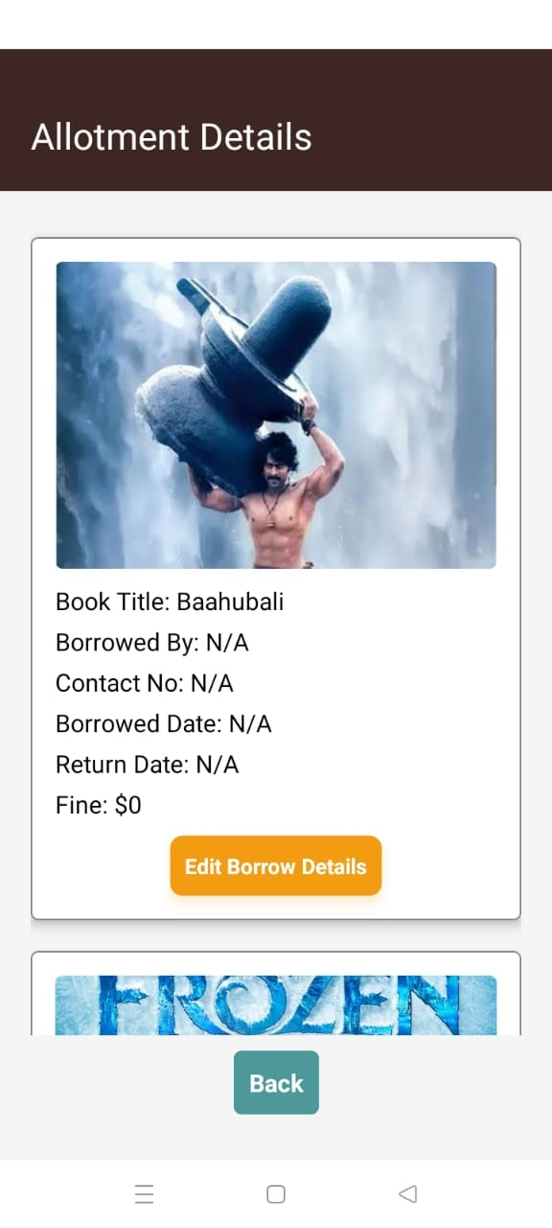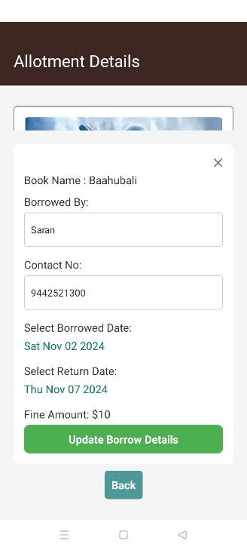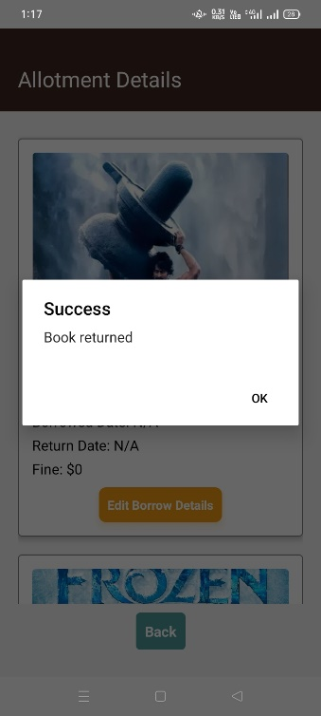
Add Book User Details Permission History
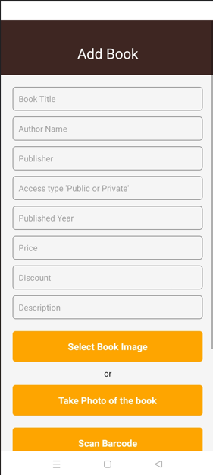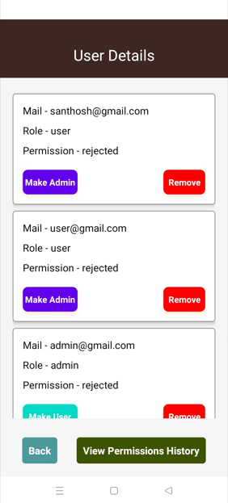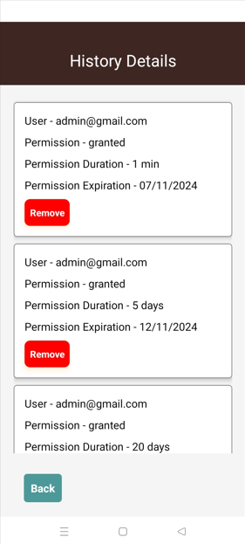
CHAPTER 4
DETAILED DESIGN

4.1 ARCHITECTURAL DESIGN
The E-Library is designed using a client-server architecture that leverages Firebase as a Backend-as-a-Service (BaaS) and React Native for the cross-platform mobile frontend. This architecture enables seamless data synchronization, secure access, and a responsive user experience.
- Frontend (Client-Side): The E-Library frontend is built with React Native, making it accessible on both iOS and Android devices. The client-side application handles user interactions, such as book browsing, request submissions, and premium subscriptions. It communicates with Firebase through API calls to fetch or update data in real time, ensuring that users always have up-to-date information.
- Backend (Server-Side): Firebase serves as the backend, managing data storage, authentication, and real-time database syncing. Firebase Authentication provides secure login for both users and administrators, with role-based access control. The Firebase Firestore database holds information about users, books, requests, and transactions, supporting real-time updates and efficient data retrieval.
- Core Modules:
  - Authentication Module: Manages secure login and access control.
  - Catalog Module: Handles book browsing, searching, and previewing.
  - Request Module: Manages book requests and approvals.
  - Payment and Fine Module: Automates fine calculation and handles payments for premium subscriptions.
4.1.1 MODULE CHARACTERISTICS
The application contains two main modules:
- User Module
- Admin Module
4.1.1.1 USER MODULE
The User Module in the E-Library provides a comprehensive interface for library users to access, request, and manage their library-related activities seamlessly. It is designed to enhance the user experience by making library services available digitally, promoting accessibility and convenience.
- Registration and Login: Users can register and log in through Firebase Authentication, enabling secure and personalized access. Login credentials (email and password) or social login options ensure secure user verification.
- Book Browsing and Search: Once logged in, users can browse the library catalog to view available books. The system provides filtering and searching capabilities, allowing users to find books by title, author, genre, or availability status.
- Book Request and Access: Users can request a book, triggering a notification to the admin for approval. Upon approval, the user gains access to the requested book for a specified time period.
- Premium Subscription: Users have the option to request a premium subscription, which grants extended access to the entire library collection. This request goes to the admin for approval, after which the user can pay through integrated payment methods.
- QR Code Scanning for Check-Ins/Check-Outs: Users can scan a QR code for fast, contactless check-ins and check-outs of physical books.
- Payment and Fines: The system calculates and displays fines for overdue returns, allowing users to make payments directly through the app.

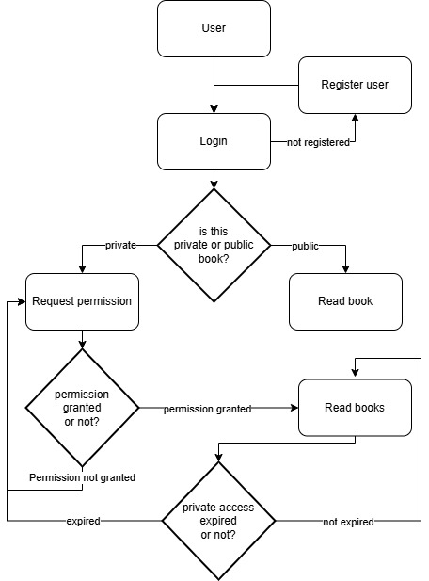
Figure 4.1 User flowchart

4.1.1.2 ADMIN MODULE
The Admin Module in the E-Library is a powerful backend interface designed for library staff to efficiently manage book inventory, user requests, and subscription services. This module enables administrators to streamline library operations by automating many routine tasks and enhancing control over the library’s resources.
- Authentication and Access Control: Admins log in securely through Firebase Authentication. This secure login restricts access to admin functionalities, ensuring only authorized personnel can manage the library.
- Catalog Management: Admins can add, edit, or delete books in the library database, updating book details, availability status, and categorization. This ensures an up-to-date catalog that users can rely on when browsing or making requests.
- User Request Management: Admins receive notifications of user requests for book access and premium subscriptions. They can approve or deny these requests directly within the module, enabling swift response times to user needs.
- Premium Subscription Management: Admins can review and approve premium subscription requests, which allow users broader access to the library’s full collection.
- QR Code Management: Admins can generate and manage QR codes for each book, facilitating fast check-ins and check-outs when users scan these codes.
- Fine Calculation and Payment Tracking: The system automatically calculates fines for overdue returns. Admins can monitor fine payments, providing transparency and easy tracking for library finances.
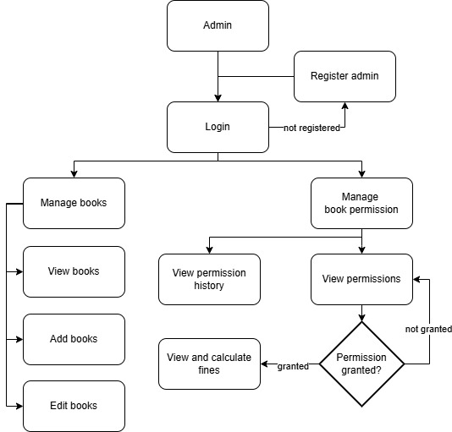
Figure 4.2 Admin flowchart

4.1.1.3 USE CASE DIAGRAM
A use case diagram is a dynamic or behaviour diagram in UML. Use case diagrams model the functionality of a system using actors and use cases. Use cases are set of actions, services, and functions that the system needs to perform. A use case diagram at its simplest is a representation of a user's interaction with the system that shows the relationship between the user and the different use cases in which the user is involved. The use cases are represented by either circles or ellipses. Due to their simplistic nature, use case diagrams can be a good communication tool for stakeholders.
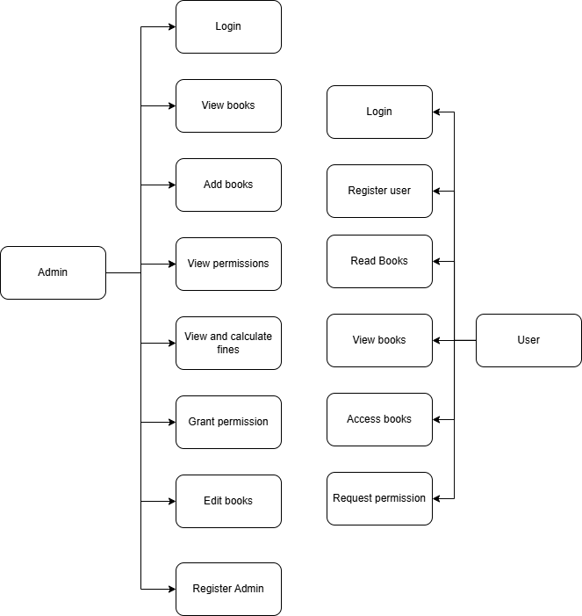
Figure 4.3 Usecase diagram

4.1.1.4 SEQUENCE DIAGRAM
The sequence diagram illustrates the interactions between the User, Admin, and System during a book request process. The User initiates the request, and the System sends the request to the Admin for approval. Once approved, the System grants the User access to the book and updates the library records accordingly.
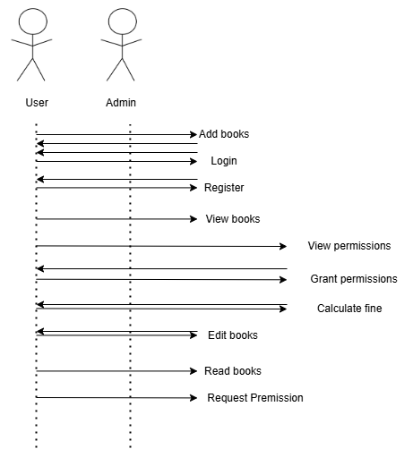
Figure 4.4 Sequence diagram

4.2 INTERFACE DESIGN
The E-Library’s interface is designed to be intuitive and accessible for both Users and Admins. The User Interface includes a login screen, book catalog with search and filter options, request and payment pages, and a QR code scanner for book check-ins/outs. The Admin Interface features options for managing the catalog, handling user requests, approving subscriptions, and viewing fines or payments. Clear navigation, visually distinct elements, and responsive design ensure that users and admins can easily perform tasks, while Firebase authentication provides a secure login experience.
4.3 DATABASE DEGIGN
The Firebase database for the E-Library is structured with collections and documents for efficient data management. Key collections include Users (storing profile, request history, subscription status), Books (holding book details, availability status, and QR code data), Requests (tracking user book requests, timestamps, and statuses), and Payments (logging fine payments and premium subscription transactions). Each document is assigned unique IDs, and real-time syncing ensures that data is immediately updated across all users. Firebase Authentication manages secure user credentials, while Firestore supports quick retrieval and scalability for large datasets.
4.4 OUTPUT DESIGN
The system outputs include real-time book availability status, request approvals, and fine or payment summaries, displayed to users and admins. Users see instant updates on request approvals, premium access, or fines, while Admins receive notifications for pending requests and subscription requests. Detailed summaries of transactions and request histories provide transparency for both users and admins. Outputs are designed to be clear and organized, utilizing Firebase’s real-time database capabilities to keep all data current and easily accessible from any device.

CHAPTER 5
TESTING

5.1 UNIT TESTING
Unit testing is the process of testing individual components or functions of a system to ensure they work as expected. In the E-Library, unit testing focuses on isolated components like user login, book search, request submission, and payment processing. Each unit test verifies a single function or method within the E-Library, such as validating user credentials, calculating fines, or querying book availability. By isolating these functions, unit testing helps identify and fix errors early, improving the reliability of individual components before they are integrated into the full system. Unit tests are automated and run frequently to maintain code quality during development.

5.2 VALIDATION TESTING
Validation testing evaluates the system’s performance against user requirements to ensure it fulfills the intended purpose. For the E-Library, this testing checks if users can perform actions like logging in, browsing books, requesting books, and making payments without issues. Admins’ actions, like adding books or approving requests, are also validated. The process involves testing the system in real-world scenarios and gathering feedback to verify that it meets all user expectations. Validation testing occurs after system integration and ensures that the E-Library provides a satisfying user experience, meeting both functional and non-functional requirements.

5.3 VERIFICATION TESTING
Verification testing assesses whether the E-Library has been developed according to specified design and requirements. This involves reviewing documentation, system specifications, and code to confirm that each component aligns with the intended architecture. For example, ensuring that Firebase is correctly configured for authentication, that the database schema matches design specifications, and that each module performs its assigned function as per the requirements. Verification testing includes code reviews and inspections, providing an early check that each part of the system has been correctly built before extensive testing begins. It confirms the E-Library’s structural correctness, reducing the chance of errors later in testing.

CHAPTER 6
CONCLUSION AND FUTURE ENHANCEMENT

The E-Library provides a robust, efficient platform for modern library management, streamlining the processes of book requests, inventory control, user authentication, and fine management. Built with React Native for cross-platform access and Firebase for real-time data management, the E-Library enhances user accessibility, providing library patrons with a convenient way to access resources online, while automating many of the administrative tasks for library staff. By integrating secure authentication, QR code scanning, premium subscription management, and automated fine calculation, the E-Library effectively meets the needs of both users and administrators, creating a seamless digital library experience. This solution reduces manual workloads, minimizes errors, and offers an engaging interface that improves overall library operations. Future enhancements could include expanding analytics and reporting features for the admin, such as tracking popular books or identifying overdue trends to optimize inventory and policies. Adding AI-driven book recommendations could enhance user experience by offering personalized suggestions based on borrowing history. Integration with external libraries or digital book providers could allow users access to a broader range of resources. Additionally, implementing multilingual support would make the E-Library more inclusive for diverse user bases. By continuing to innovate, the E-Library can evolve into a comprehensive tool that supports the dynamic needs of digital libraries.

APPENDIX 1

App.js
import React, { useEffect, useState } from "react";
import { createStackNavigator } from "@react-navigation/stack";
import RouterStack from "./Navigation/Routerstack";
import { connectToDatabase } from "./firebase";
import SplashScreen from "./screens/SplashScreen";
import ErrorScreen from "./screens/ErrorScreen"
import { checkconnection } from "./internetconnection";

const Stack = createStackNavigator();

const App = () => {
const [internetstatus , setInternetstatus] = useState(false);
const [loading, setLoading] = useState(true);

const handleCheckConnection = async () => {
const res = await checkconnection();
setInternetstatus(res);
};

useEffect(() => {
handleCheckConnection();
}, []);

useEffect(() => {
const fetchData = async () => {
await new Promise((resolve) => setTimeout(resolve, 1500));

let connected = false;
const startTime = new Date().getTime();
const timeout = 20000;

while (!connected && new Date().getTime() - startTime < timeout) {
try {
await connectToDatabase();
connected = true;
setLoading(false);
} catch (err) {
console.error("Failed to connect Firestore: ", err);
}
}

if (!connected) {
setLoading(false);
}
};

fetchData();
}, []);
return loading ? <SplashScreen /> : internetstatus ? <RouterStack /> : <ErrorScreen onCheck={handleCheckConnection}/>;
};
export default App;

UserScreen.js
import React, { useState, useEffect } from "react";
import {
View,
Text,
TouchableOpacity,
SafeAreaView,
StyleSheet,
ActivityIndicator,
Alert,
FlatList,
Image,
Modal,
} from "react-native";
import { Picker } from "@react-native-picker/picker";69
import { auth, connectToDatabase } from "../firebase";
import { signOut } from "firebase/auth";
import { collection, getDocs, doc, getDoc, updateDoc } from "firebase/firestore";

export default function UserScreen({ navigation }) {
const db = connectToDatabase();
const [loading, setLoading] = useState(false);
const [books, setBooks] = useState([]);
const [error, setError] = useState("");
const [id, setId] = useState(null);
const [selectedBookId, setSelectedBookId] = useState(null);
const [userPermissionStatus, setUserPermissionStatus] = useState(null);
const [permissionDurationStatus, setPermissionDurationStatus] = useState(null);
const [loadingPermissionId, setLoadingPermissionId] = useState(null); // New state for permission request loading
const [modalVisible, setModalVisible] = useState(false);
const [selectedDays, setSelectedDays] = useState("1 day");

// Fetch user's permission status from Firestore
const fetchUserPermissionStatus = async () => {
try {
const userDocRef = doc(db, "users", auth.currentUser.uid);
const userDoc = await getDoc(userDocRef);
if (userDoc.exists()) {
const userData = userDoc.data();
setUserPermissionStatus(userData.permission || "none");
setPermissionDurationStatus(userData.permissionduration);
} else {
setUserPermissionStatus("none");
}
} catch (error) {
console.error("Error fetching user permission status:", error);
}
};

const fetchBooks = async () => {
setLoading(true);
try {
const booksCollection = collection(db, "books");
const bookSnapshot = await getDocs(booksCollection);
const bookList = bookSnapshot.docs.map((doc) => ({
id: doc.id,
...doc.data(),
}));
setBooks(bookList);
} catch (error) {
setError("Failed to load books.");
} finally {
setLoading(false);
}
};

useEffect(() => {
fetchBooks();
fetchUserPermissionStatus();

const intervalId = setInterval(() => {
fetchUserPermissionStatus();
},1000);

return () => clearInterval(intervalId);
}, []);

// Handle sign out
const handleSignOut = () => {
setLoading(true);
signOut(auth)
.then(() => {
setLoading(false);
navigation.replace("Login");
})
.catch((error) => {
setLoading(false);
Alert.alert("Error", error.message);
});
};

const handleRequest = async (Id) => {
setId(Id);
setModalVisible(true);
};
// Handle permission request for private books
const handlePermissionRequest = async () => {
setLoadingPermissionId(id); // Start loading for the specific book
try {
const userDocRef = doc(db, "users", auth.currentUser.uid);
await updateDoc(userDocRef, {
permission: "pending", // Mark permission as pending
permissionduration: selectedDays, // Mark permission as pending
requestedBookId: id, // Store the ID of the book being requested
});
Alert.alert("Permission Request Sent", "Your request is now pending.");
setUserPermissionStatus("pending"); // Update local state
setModalVisible(false);
} catch (error) {
console.error("Error requesting permission:", error);
Alert.alert("Error", "Could not send the permission request.");
} finally {
setLoadingPermissionId(null); // Reset loading state
}
};

// Handle book image press to toggle details view
const handleImagePress = (bookId) => {
setSelectedBookId((prevSelectedBookId) =>
prevSelectedBookId === bookId ? null : bookId
);
};

return (
<SafeAreaView style={styles.container}>
<View style={styles.header}>
<Text style={styles.title}>Books</Text>
<TouchableOpacity style={styles.btnSignOut} onPress={handleSignOut}>
<Text style={styles.btnText}>Sign Out</Text>
</TouchableOpacity>
</View>

<View style={styles.content}>
{loading && (
<View style={styles.loadingContainer}>
<Text style={styles.loadingText}>Loading Book Details...</Text>
<ActivityIndicator size="large" color="#0000ff" />
</View>
)}

{error ? (
<Text style={styles.errorText}>{error}</Text>
) : (
<FlatList
data={books}
keyExtractor={(item) => item.id}
renderItem={({ item }) => (
<View style={styles.bookItem}>
<Text style={styles.bookTitle}>{item.title}</Text>
<TouchableOpacity onPress={() => handleImagePress(item.id)}>
<Image
source={{ uri: item.imageUrl }}
style={styles.bookImage}
/>
</TouchableOpacity>

{selectedBookId === item.id ? (
item.accesstype === "Public" ? (
<>
<Text style={styles.bookText}>
Book Title: {item.title}
</Text>
<Text style={styles.bookText}>
Author: {item.authorname}
</Text>
<Text style={styles.bookText}>
Publisher: {item.publisher}
</Text>
<Text style={styles.bookText}>
Published Year: {item.publishedyear}
</Text>
<Text style={styles.bookText}>ID: {item.bookId}</Text>
<Text style={styles.bookText}>Status: {item.status}</Text>
<Text style={styles.bookText}>
Price: {item.price}
</Text>
<Text style={styles.bookText}>
Discount: {item.discount}
</Text>
<Text style={styles.bookText}>
Description: {item.description}
</Text>
{item.barcode && (
<Text style={styles.bookText}>
Barcode: {item.barcode}
</Text>
)}
</>
) : (
<>
{userPermissionStatus === "granted" ? (
<>
<Text>Permission Status: {userPermissionStatus}</Text>
<Text>Permission Granted for {permissionDurationStatus}.</Text>
<Text style={styles.bookText}>
Book Title: {item.title}
</Text>
<Text style={styles.bookText}>
Author: {item.authorname}
</Text>
<Text style={styles.bookText}>
Publisher: {item.publisher}
</Text>
<Text style={styles.bookText}>
Published Year: {item.publishedyear}
</Text>
<Text style={styles.bookText}>ID: {item.bookId}</Text>
<Text style={styles.bookText}>
Price: {item.price}
</Text>
<Text style={styles.bookText}>
Discount: {item.discount}
</Text>
<Text style={styles.bookText}>
Description: {item.description}
</Text>
{item.barcode && (
<Text style={styles.bookText}>
Barcode: {item.barcode}
</Text>
)}
</>
) : (
userPermissionStatus === "pending" ? (
<>
<Text>
This is private; you need permission to see this
content.
</Text>
<Text>Permission Status: {userPermissionStatus}</Text>
</>
):(
<>
<Text>
This is private; you need permission to see this
content.
</Text>
<Text>Permission Status: {userPermissionStatus}</Text>
<TouchableOpacity
style={styles.btnPermission}
onPress={() => handleRequest(item.id)}
disabled={loadingPermissionId === item.id} // Disable button when loading
>
{loadingPermissionId === item.id ? ( // Show activity indicator if loading
<ActivityIndicator size="small" color="#ffffff" />
) : (
<Text style={styles.btnText}>Request Permission</Text>
)}
</TouchableOpacity>
</>
)
)}
</>
)
) : null}
</View>
)}
contentContainerStyle={styles.listContainer}
/>
)}
</View>

<Modal
animationType="slide"
transparent={true}
visible={modalVisible}
onRequestClose={() => setModalVisible(false)}
>
<View style={styles.modalView}>
<Text style={styles.modalText}>Select Duration:</Text>
<Picker
selectedValue={selectedDays}
style={styles.picker}
onValueChange={(itemValue) => setSelectedDays(itemValue)}
>
<Picker.Item label="1 min" value="1 min" />
<Picker.Item label="1 day" value="1 day" />
<Picker.Item label="5 days" value="5 days" />
<Picker.Item label="10 days" value="10 days" />
<Picker.Item label="20 days" value="20 days" />
<Picker.Item label="30 days" value="30 days" />
<Picker.Item label="50 days" value="50 days" />
</Picker>
<TouchableOpacity
style={styles.grantPermissionButton}
onPress={handlePermissionRequest}
>
<Text style={styles.buttonText}>Request Permission</Text>
</TouchableOpacity>
<TouchableOpacity
style={styles.cancelButton}
onPress={() => setModalVisible(false)}
>
<Text style={styles.buttonText}>Cancel</Text>
</TouchableOpacity>
</View>
</Modal>
</SafeAreaView>
);
}

const styles = StyleSheet.create({
container: {
flex: 1,
backgroundColor: "#f5f5f5",
},
header: {
padding: 20,
paddingTop: 40,
backgroundColor: "#3e2723",
flexDirection: "row",
justifyContent: "space-between",
alignItems: "center",
},
title: {
fontSize: 24,
color: "#ffffff",
},
content: {
flex: 1,
width: "100%",
padding: 20,
},
loadingContainer: {
flex: 1,
justifyContent: "center",
alignItems: "center",
},
loadingText: {
marginTop: 10,
fontSize: 18,
color: "#0000ff",
},
btnSignOut: {
backgroundColor: "#841584",
paddingVertical: 10,
borderRadius: 8,
width: "48%",
alignItems: "center",
shadowColor: "#f39c12",
shadowOffset: { width: 0, height: 4 },
shadowOpacity: 0.3,
shadowRadius: 4,
elevation: 6,
},
btnText: {
color: "#ffffff",
fontSize: 16,
fontWeight:'700',
textAlign:'center',
},
errorText: {
color: "red",
textAlign: "center",
},
bookItem: {
marginVertical: 10,
padding: 15,
borderRadius: 8,
backgroundColor: "#ffffff",
elevation: 1,
},
bookText: {
fontSize: 16,
},
bookTitle: {
fontSize: 18,
fontWeight: "bold",
},
bookImage: {
width: "100%",
height: 200,
borderRadius: 8,
marginVertical: 10,
},
btnPermission: {
backgroundColor: "#007bff",
padding: 10,
borderRadius: 5,
marginTop: 10,
paddingVertical: 8,
borderRadius: 8,
width: "95%",
alignItems: "center",
shadowColor: "#f39c12",
shadowOffset: { width: 0, height: 4 },
shadowOpacity: 0.3,
shadowRadius: 4,
elevation: 6,
},
listContainer: {
paddingBottom: 20,
},
modalView: {
margin: 20,
backgroundColor: "white",
borderRadius: 20,
padding: 35,
alignItems: "center",
shadowColor: "#000",
shadowOffset: {
width: 0,
height: 2,
},
shadowOpacity: 0.25,
shadowRadius: 4,
elevation: 5,
},
modalText: {
marginBottom: 15,
textAlign: "center",
fontSize: 18,
},
picker: {
height: 50,
width: 200,
marginBottom: 15,
},
grantButton: {
backgroundColor: "#4caf50",
paddingVertical: 10,
borderRadius: 8,
width: "20%",
alignItems: "center",
shadowColor: "#f39c12",
marginLeft:10,
shadowOffset: { width: 0, height: 4 },
shadowOpacity: 0.3,
shadowRadius: 4,
elevation: 6,
},
grantPermissionButton: {
backgroundColor: "#4caf50",
paddingVertical: 10,
borderRadius: 8,
width: "40%",
alignItems: "center",
shadowColor: "#f39c12",
marginLeft:10,
marginBottom:10,
shadowOffset: { width: 0, height: 4 },
shadowOpacity: 0.3,
shadowRadius: 4,
elevation: 6,
},
cancelButton: {
backgroundColor: "red",
paddingVertical: 10,
borderRadius: 8,
marginLeft:10,
width: "25%",
alignItems: "center",
shadowColor: "#f39c12",
shadowOffset: { width: 0, height: 4 },
shadowOpacity: 0.3,
shadowRadius: 4,
elevation: 6,
},
});

APPENDIX 2
SNAPSHOTS
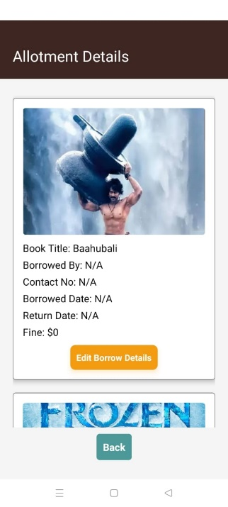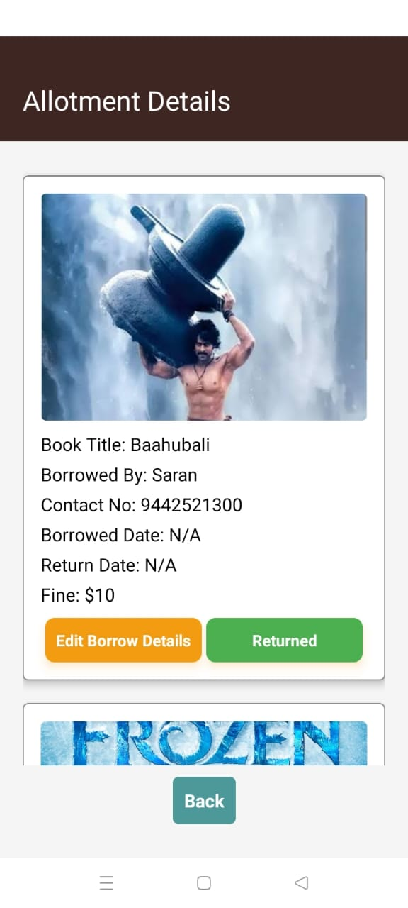
Figure A2.1 Home page allotment Figure A2.2 Home page borrowing book
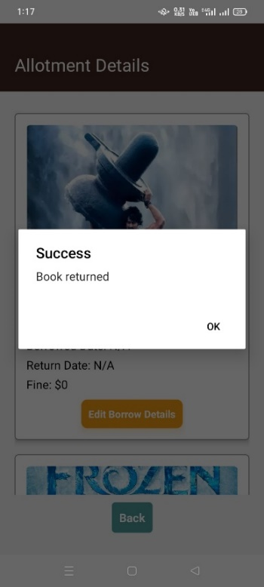
Figure A2.3 Home page Book returning

Figure A3.4 Book borrow history Figure A2.5 User details


Figure A2.6 Adding book
REFERENCES

[1] P. Käld and O. Svensson, "React Native and Native Application Development: A Comparative Study Based on Features & Functionality When Measuring Performance in Hybrid and Native Applications," Bachelor's thesis, Dept. of Comput. Sci. and Informatics, Jönköping Univ., Sch. of Eng., Jönköping, Sweden, 2021.

[2] E. Ramadhani, "Design and Implementation of Mobile Native Application," Bachelor's thesis, 2021.

[3] H.-Y. Yoon, "User acceptance of mobile library applications in academic libraries: An application of the technology acceptance model," J. Acad. Librarianship, vol. 42, no. 6, pp. 687–693, Nov. 2016. Available: https://doi.org/10.1016/j.acalib.2016.08.003

[4] A. Shatte, J. Holdsworth, and I. Lee, "Mobile augmented reality-based context-aware library management system," Expert Syst. Appl., vol. 41, no. 5, pp. 2174–2185, Mar. 2014. Available: https://doi.org/10.1016/j.eswa.2013.09.002

[5] W. Danielsson, "React Native application development: A comparison between native Android and React Native," Master's thesis, Dept. of Comput. and Inf. Sci., Linköping Univ., Linköping, Sweden, 2016.

[6] B. A. Zainal, "Developing a library management system for managing the books: A suggested model in the Central Library of Cihan University-Erbil," Int. J. Adv. Sci. Technol., vol. 28, no. 13, pp. 559–578, 2019.

